Paul Minniti
COSC 120
Lab #7
3-26-15

Lab report: I have finished all the tasks of the lab by my own. I have had no problem working out the questions. It took me approximately 3:30 hours/minutes to work on it.

Lab 5.1

Exercise 1:

[Source code ]

// This program will read in a group of test scores( positive integers from 1 to 100)
// from the keyboard and then calculates and outputs the average score
// as well as the highest and lowest score. There will be a maximum of 100 scores.

// Paul Minniti

#include <iostream>
using namespace std;

typedef int GradeType[100]; // declares a new data type:
// an integer array of 100 elements

float findAverage (const GradeType, int); // finds average of all grades
int findHighest (const GradeType, int); // finds highest of all grades
int findLowest (const GradeType, int); // finds lowest of all grades

int main()

{
GradeType grades; // the array holding the grades.
int numberOfGrades; // the number of grades read.
int pos; // index to the array.

float avgOfGrades; // contains the average of the grades.
int highestGrade; // contains the highest grade.
int lowestGrade; // contains the lowest grade.

// Read in the values into the array

pos = 0;
cout << "Please input a grade from 1 to 100, (or -99 to stop)" << endl;
cin >> grades[pos];

while (grades[pos] != -99)
{

// Fill in the code to read the grades
pos++;
cin >> grades[pos];
}

numberOfGrades = pos; // Fill blank with appropriate identifier

// call to the function to find average

avgOfGrades = findAverage(grades, numberOfGrades);

cout << endl << "The average of all the grades is " << avgOfGrades << endl;

// Fill in the call to the function that calculates highest grade
highestGrade = findHighest(grades, numberOfGrades);

cout << endl << "The highest grade is " << highestGrade << endl;

// Fill in the call to the function that calculates lowest grade
lowestGrade = findLowest(grades, numberOfGrades);
// Fill in code to write the lowest to the screen
cout << endl << "The lowest grade is " << lowestGrade << endl;
return 0;
}

//****************************************************************************
// findAverage
//
// task: This function receives an array of integers and its size.
// It finds and returns the average of the numbers in the array
// data in: array of floating point numbers
// data returned: avarage of the numbers in the array
//
//****************************************************************************

float findAverage (const GradeType array, int size)

{

float sum = 0; // holds the sum of all the numbers

for (int pos = 0; pos < size; pos++)

sum = sum + array[pos];

return (sum / size); //returns the average

}

//****************************************************************************
// findHighest
//
// task: This function receives an array of integers and its size.
// It finds and returns the highest value of the numbers in
// the array
// data in: array of floating point numbers
// data returned: highest value of the numbers in the array
//
//****************************************************************************

int findHighest (const GradeType array, int size)

{
int highest = 0;
for (int pos = 0; pos < size; pos++)
if (array[pos]>highest)
highest = array[pos];
return highest;
// Fill in the code for this function

}

//****************************************************************************
// findLowest
//
// task: This function receives an array of integers and its size.
// It finds and returns the lowest value of the numbers in
// the array
// data in: array of floating point numbers
// data returned: lowest value of the numbers in the array
//
//****************************************************************************

int findLowest (const GradeType array, int size)

{

// Fill in the code for this function
int low=0;
for (int pos = 0; pos > size; pos++)
if (array[pos]<low)
low = array[pos];
return low;
}

[sample output]

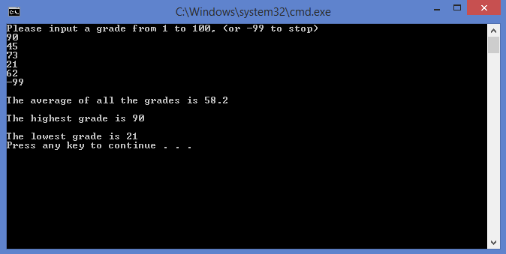

Lab 5.2

Exercise 1:

[Source code ]

// This program will input an undetermined number of student names
// and a number of grades for each student. The number of grades is
// given by the user. The grades are stored in an array.
// Two functions are called for each student.
// One function will give the numeric average of their grades.
// The other function will give a letter grade to that average.
// Grades are assigned on a 10 point spread.
// 90-100 A 80- 89 B 70-79 C 60-69 D Below 60 F

// Paul Minniti

#include <iostream>
using namespace std;

const int MAXGRADE = 25; // maximum number of grades per student
const int MAXCHAR = 30; // maximum characters used in a name

typedef char StringType30[MAXCHAR + 1];// character array data type used for names
// having 30 characters or less.
typedef float GradeType[MAXGRADE]; // one dimensional integer array data type

float findGradeAvg(GradeType, int); // finds grade average by taking array of
// grades and number of grades as parameters

char findLetterGrade(float); // finds letter grade from average given
// to it as a parameter

int main()

{
StringType30 firstname, lastname; // two arrays of characters defined
int numOfGrades; // holds the number of grades
GradeType grades; // grades is defined as a one dimensional array
float average; // holds the average of a student's grade
char moreinput; // determines if there is more input

// Input the number of grades for each student

cout << "Please input the number of grades each student will receive." << endl
<< "This number must be a number between 1 and " << MAXGRADE << " inclusive" << endl;

cin >> numOfGrades;

while (numOfGrades > MAXGRADE || numOfGrades < 1)
{
cout << "Please input the number of grades for each student." << endl
<< "This number must be a number between 1 and " << MAXGRADE << " inclusive" << endl;

cin >> numOfGrades;

}

// Input names and grades for each student

cout << "Please input a y if you want to input more students"
<< " any other character will stop the input" << endl;
cin >> moreinput;

while ( moreinput == 'y' || moreinput == 'Y')

{
cout << "Please input the first name of the student" << endl;
cin >> firstname;
cout << endl << "Please input the last name of the student" << endl;
cin >> lastname;

for (int count = 0; count < numOfGrades; count++)

{

cout << endl << "Please input a grade" << endl;

// Fill in the input statement to place grade in the array
cin >> grades[count];
}

cout << firstname << ' ' << lastname << " has an average of ";

// Fill in code to get and print average of student to screen
findGradeAvg(grades, numOfGrades);
average = findGradeAvg(grades, numOfGrades);
cout << average << "";
// Fill in call to get and print letter grade of student to screen
char grade = findLetterGrade(average);
cout << "which earns the Letter grade " << grade << endl;
cout << endl << endl << endl;
cout << "Please input a y if you want to input more students"
<< " any other character will stop the input" << endl;
cin >> moreinput;

}

return 0;
}

//***********************************************************************
// findGradeAvg
//
// task: This function finds the average of the
// numbers stored in an array.
//
// data in: an array of integer numbers
// data returned: the average of all numbers in the array
//
//***********************************************************************

float findGradeAvg(GradeType array, int numgrades)

{

// Fill in the code for this function
int count;
float sum = 0;

for (count = 0; count < numgrades; count++)
sum = sum + array[count];

return(sum / numgrades);

}

//***********************************************************************
// findLetterGrade
//
// task: This function finds the letter grade for the number
// passed to it by the calling function
//
// data in: a floating point number
// data returned: the grade (based on a 10 point spread) of the number
// passed to the function
//
//***********************************************************************

char findLetterGrade(float numgrade)

{

// Fill in the code for this function

char grades;

if (numgrade < 60)
return 'F';
else if (numgrade < 70)
return 'D';
else if (numgrade < 80)
return 'C';
else if (numgrade < 90)
return 'B';
else if (numgrade < 100)
return 'A';
else if (numgrade != 0 || numgrade != 100)
return grades;
}

[sample output]

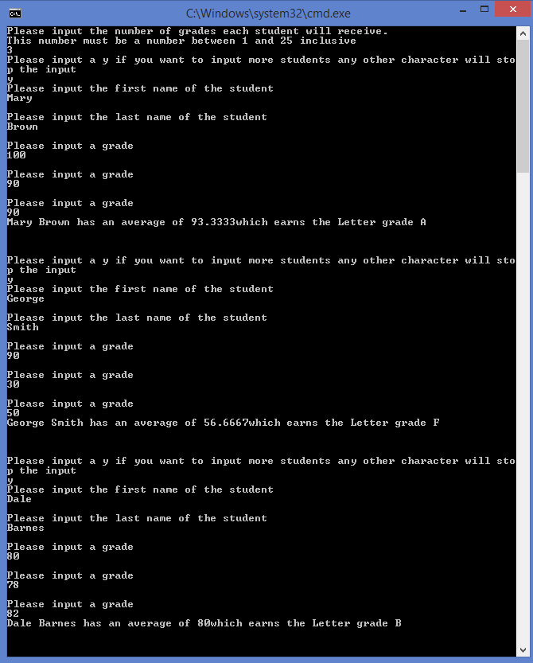
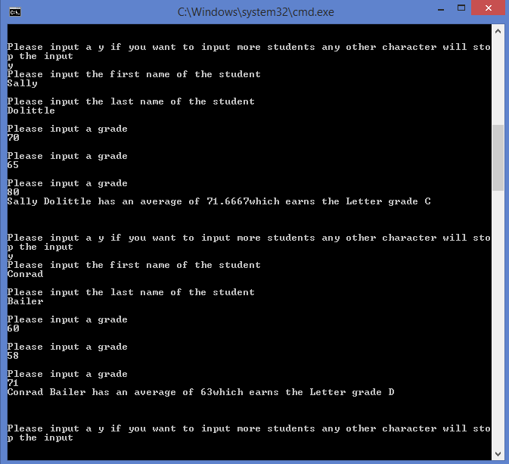

Lab 5.3

Exercise 1:

[Source code ]

// This program will read in prices and store them into a two-dimensional array
// It will print those prices in a table form.

// Paul Minniti

#include <iostream>
#include <iomanip>
using namespace std;

const int MAXROWS = 10;
const int MAXCOLS = 10;

typedef float PriceType[MAXROWS][MAXCOLS]; // creates a new data type
// of a 2D array of floats

void getPrices(PriceType, int&, int&); // gets the prices into the array
void printPrices(PriceType, int, int); // prints data as a table

int main()

{
int rowsUsed; // holds the number of rows used
int colsUsed; // holds the number of columns used
PriceType priceTable; // a 2D array holding the prices

getPrices(priceTable, rowsUsed, colsUsed); // calls getPrices to fill the array
printPrices(priceTable, rowsUsed, colsUsed);// calls printPrices to display array

return 0;
}

//*********************************************************************************
// getPrices
//
// task: This procedure asks the user to input the number of rows and
// columns. It then asks the user to input (rows * columns) number
// of prices where x = rows * columns. The data is placed in the array.
// data in: none
// data out: an array filled with numbers and the number of rows
// and columns used.
//
//********************************************************************************

void getPrices(PriceType table, int& numOfRows, int& numOfCols)

{

cout << "Please input the number of rows from 1 to "<< MAXROWS << endl;
cin >> numOfRows;

cout << "Please input the number of columns from 1 to "<< MAXCOLS << endl;
cin >> numOfCols;

float price = 0;
for (int row = 0; row < numOfRows; row++)
{
for (int col = 0; col < numOfCols; col++)
{
// Fill in the code to read and store the next value in the array
cout << "Please input the price of an item to the second decimal" << endl;
cin >> price;
table[row][col] = price;
}
}
}

//***************************************************************************
// printPrices
//
// task: This procedure prints the table of prices
// data in: an array of floating point numbers and the number of rows
// and columns used.
// data out: none
//
//****************************************************************************

void printPrices(PriceType table, int numOfRows, int numOfCols)

{

cout << fixed << showpoint << setprecision(2);

for (int row = 0; row < numOfRows; row++)
{
for (int col = 0; col < numOfCols; col++)
// Fill in the code to print the table
{
float temp = table[row][col];
cout << "/t" << temp;
}
cout << endl;

}
}

